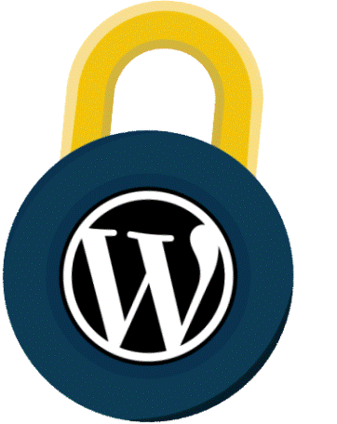
The Ultimate WORDPRESS SECURITY Checklist [2019]

Part 1: Simple Steps to Secure WordPress

ALWAYS Keep Your Version of WordPress Up-To-Date

- Don’t Change WordPress Core

- Make Sure All Your Plugins Are Updated

- Remove Any Inactive or Unused Plugins

- Make Sure All Themes Are Kept Updated

- Install Themes, Plugins and Scripts ONLY From Their Official Source

- Choose a Secure WordPress Hosting Service

- Make Sure Your Site is Running the Latest Version of PHP

- Change the Admin Username

- Always Use Strong Passwords

- Don’t Reuse Passwords

- Protect Your Password(s) By Avoiding Plain-Text Password Transmission

- Only Update Your Site From Trusted Networks

- Use a Local Anti-Virus

- Enable Google Search Console

- Secure WordPress With a Bulletproof WordPress Security Plugin

- If All Else Fails, Restore From Backup

SECURITY:

Ultimate 32-Step Checklist

Part 2: Advanced Steps for Security Freaks

. Limit Login Attempts

- Enable Two-Factor Authentication

- Ensure File Permissions Are Correct

- Change the Default Table Prefix

- Ensure You’ve Set WordPress Secret Authentication Keys

- Disable PHP Execution

- Segregate Your WordPress Databases

- Restrict Database User Privileges

- Disable File Editing

- Secure Your wp-config.php File

- Disable XML-RPC (If You Aren’t Using It)

- Disable PHP Error Reporting

- Install a Firewall

- Use a Content Delivery Network Firewall

- Monitor Your WordPress Security With Security Logging

Part 3: Steps for Webmasters

HOSTING

Ideally on a dedicated instance or server
For shared hosting, ensure that sites are isolated or “jailed”
Run an https-only website

USER MANAGEMENT

Grant only as much access as is needed

Review your user list frequently, deleting those that are obsolete, downgrading roles where possible

WORDPRESS CORE, THEMES AND PLUGINS

Enable auto-updates wherever possible / practical

Check for updates frequently (at least weekly) and install them as soon as possible. Only download themes and plugins from trusted sources

Remove all unused themes, plugins and old unused WordPress installations immediately

AUTHENTICATION

Ideally use 2-factor authentication

Require strong passwords for all users

Ensure that your login page is running on an https page

Limit the rate of login attempts

SERVER ADMINISTRATION

Only communicate with your server using an encrypted connection (sFTP for file transfer or SSH for shell access)

If you connect to your server over a public network, use a VPN

SERVER ADMINISTRATION (CONTINUED)

Secure access to your wp-config.php file, including copies
Secure access to your backups, log files, test files, temporary files and other PHP applications on your web server

Backup your WordPress files and database at least weekly

Use a strong password for your MySQL database user

Install a WordPress security plugin

FEATURES TO LOOK FOR IN A WORDPRESS SECURITY PLUGIN

Malware scanning Brute-force login protection

Protection against hacker recon techniques

Rate based throttling and blocking

Two-factor authentication

Password auditing

Country blocking

Advanced blocking techniques

SECURE YOUR WORK ENVIRONMENT

Protect your internet connection by using a VPN, especially on public networks

Only install trusted software on your workstation and mobile device

Use a reputable virus scanner

Protect your devices with strong passwords

Watch out for phishing, spear phishing and social engineering attacks

TAKE STEPS TO DETECT HACKS EARLY

Visit your site often

Search for your website in Google frequently

Set up email alerts in Google Search Console

Use a malware scanner like WP hacked Help and set up email alerts

Investigate customer reports immediately
Use a source code scanner to verify site integrity

Use a website monitoring service that detects site changes

Watch for unexplained spikes in site traffic

Also See Our Top Rated Posts

Best WordPress Security Services & Plugins 2019 - How To Choose

How To Setup WordPress Two-Factor Authentication (2FA)

Virtual Hardening & WAF 🛡️ How Does It Hardens WordPress?

How to Fix Error Establishing a Database Connection in WordPress?

WordPress Pharma Hack What It is & How To Fix It?

Website Security For Small Business - A Big Concern in 2019

How To Disable Directory Browsing in WordPress Via .htaccess & Plugins

WordPress Arbitrary File Deletion Vulnerability Exploit FIXED

